|  |
| --- |
|  |

Lost & Stolen Device Subsystem 1.0.0

User Guide

LSDS-User-Guide-1.0.0

June 19, 2018

|  |  |  |
| --- | --- | --- |
| Revision | Date | Description |
| A |  | Initial release |

Revision history

# **Contents**

1. Introduction 5

1.1. Purpose 5

1.2. Supported Desktop Browsers 5

1.3. Supported Mobile Browsers 6

1.4. Definitions, Acronyms, and Abbreviations 6

2. System Description 7

3. System Navigation 9

3.1. Log-In Screen 9

3.2. Portal Overview 10

3.3. Register New Case 11

3.3.1.IMEI Known 12

3.3.1.1.Adding Incident & User Information 17

3.3.2.IMEI Unknown 19

3.4. Search Cases 22

3.5. View All Cases 23

3.5.1.View Pending Case 23

3.5.1.1.Update Case 26

3.5.1.2.Block Case 29

3.5.1.3.Recover Case 31

3.5.2.View Blocked Cases 33

3.5.3.View Recovered Cases 34

Figures

Figure 1–Login Screen 9

Figure 2–Portal Sections 10

Figure 3–New Case 11

Figure 4–IMEI Known 12

Figure 5–Add MSISDN 12

Figure 6–Affected IMEI(s) 13

Figure 7– Add IMEI(s) 14

Figure 8–Get Details 15

Figure 9–Show Device Details 15

Figure 10–Show Device Details 16

Figure 11–Personal Details 17

Figure 12–View Registered Case 18

Figure 13–Unknown IMEI(s 19

Figure 14–Add MSISDN(s) 20

Figure 15–Fetch IMEI(s) 20

Figure 16–Verify Associated IMEI(s) 21

Figure 17–Device Details 21

Figure 18–Search Cases 22

Figure 19–Pending Cases 23

Figure 20–Case Identifier 24

Figure 21–Reported Case Details page 25

Figure 22–Update Case 26

Figure 23–Update Personal Detail 27

Figure 24–View Updated Case 28

Figure 25–Block Case 29

Figure 26–Update Comments of Pending Case 29

Figure 27–View Blocked Cases 30

Figure 28–Recover Case 31

Figure 29–Add Comments 32

Figure 30–Recovered Case Status 32

Figure 31–List of Blocked Cases 33

Figure 32–List of Recovered Cases 34

Tables

Table 1- Supported Desktop Browsers 5

Table 2- Suppored Mobile Browsers 6

Table 3-Definitions, Acronyms, and Abbreviations 6

Table 4-System Description 7

# **Introduction**

Lost & Stolen Device Subsystem (LSDS) is the subsystem of the Device Identification, Registration and Blocking System (DIRBS). It provides a platform for an authorized entity, to register a report for lost/stolen device(s) of an affected consumer and generate a unique case identifier.

The Device Identification, Registration & Blocking System (DIRBS) is a country-wide system deployed in cooperation between the country regulator, operators in that country, and a technology partner that supports deployment. The system checks, identifies, and discourages non-compliant devices by verifying the installed base of devices currently active in a market and continuing to monitor as new devices are activated.

DIRBS can verify that:

* Devices have properly allocated identifiers and type approval
* Devices are not duplicated or stolen
* Device importation takes place through legal channels

## **Purpose**

This document is intended to give assistance to the user to use the Lost & Stolen Device Subsystem (LSDS)

## **Supported Desktop Browsers**

Table 1-Supported Desktop Browsers

|  |  |
| --- | --- |
| **Name** | **Version** |
| Internet Explorer | 11.0 |
| Firefox 52.5 ESR | 57.0 |
| Chrome | 63.0 |
| Safari | 11.0 |
| Edge | 41.16299 |

## **Supported Mobile Browsers**

Table 2-Suppored Mobile Browsers

|  |  |
| --- | --- |
| **Name** | **Version** |
| Chrome | 63.0 |
| UC Browser | 11.5 |
| Opera(Android) | 44.1 |
| Opera(iOS) | 16.0.7 |
| Safari | 11.1 |
| Samsung Internet | 6.2 |
| Android | 4.1.x - 4.3 |

## **Definitions, Acronyms, and Abbreviations**

Table 3-Definitions, Acronyms, and Abbreviations

|  |  |
| --- | --- |
| Term | Definition |
| IAM | Identity Access Management |
| DIRBS | Device Identification, Registration and Blocking System |
| LSDS | Lost & Stolen Device Subsystem |
| MSISDN | Mobile Subscriber Integrated Services Directory Number |
| IMEI | International Mobile Equipment Identity |

# **System Description**

Table 4-System Description

|  |  |
| --- | --- |
| ****Feature**** | ****Explanation**** |
| Login Screen | * To access the system, authorized user first needs to enter his/her credentials on login page, this login page authenticates user from the IAM and redirects user to LSDS |
| Portal Sections | **The portal is divided into following sections:**   * **Header**   Header section displays the name of the system, name of the logged in user with logout functionality   * **Navigation Panel**   Navigation Panel contains main navigation menu through which user can navigate the whole system   * **Main Content Area**   Main Content Area contains all the content to be displayed and actions to be performed for respective feature   * **Breadcrumbs**   Breadcrumbs allows user to keep track of their location within the system   * **Footer**   Footer contains the software version and copyright statement |
| New Case | * Facilitate the user to report the affected IMEI(s) and generate a Unique Case Identifier |
| Required Input(s) for New Case Registration | * **Brand**   Takes brand name of the device as input. Enter the brand name of the lost/stolen device   * **Model Name**   Takes the Model name of the device as input. Enter model name of the lost/stolen device   * **Physical description**   The other relevant details related to the device (i.e. color etc.)   * **IMEI known (radio button)**   A control element allows to choose only one of a predefined set of mutually exclusive options   * **Affected MSISDN**   Takes the affected MSISDN as input. Enter the associated MSISDN of lost/stolen device   * **Affected IMEI**   Takes the affected IMEI as input. Enter IMEI of lost/stolen device |
| Search Case | * Allows user to search a particular case by applying different filters i.e. case identifier, last updated, case status, affected IMEIs/MSISDNs, date of incident, brand, model Name |
| All Cases | * Display the details of all reported cases i.e. pending cases, blocked cases, recovered cases |
| Pending Case | * Display pending cases along with all possible actions which could be taken on pending cases i.e. update, recover, and block. |
| Blocked Cases | * Display blocked cases along with possible actions which could be taken on pending cases i.e. recover |
| Recovered Case | * Display all recovered cases |

# **System Navigation**

## **Log-In Screen**

1. **Enter your credentials i.e. Username and Password**
2. **Click on the “Log in” button**

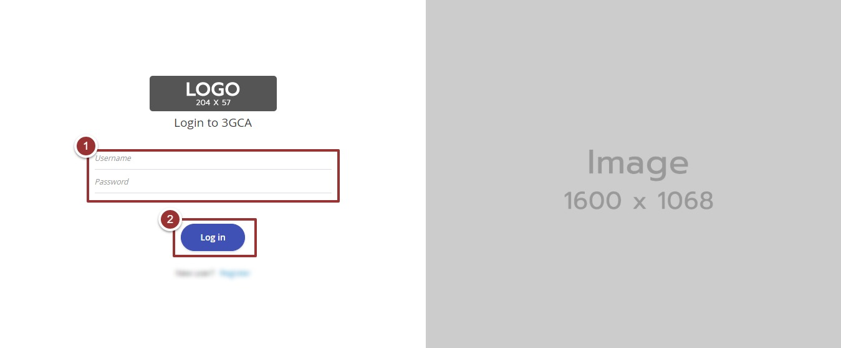

Figure 1–Login Screen

## **Portal Overview**

The portal screen is divided into following section

1. **Header** section displays the name of the system, name of the logged in user with logout functionality
2. **Main Navigation Panel** helps user to navigate the system
3. **Breadcrumbs** is a navigational aid in UI
4. **Main Content Area** contains all relevant information related to the respective feature/option
5. **Footer** contains the version and copyrights of the system

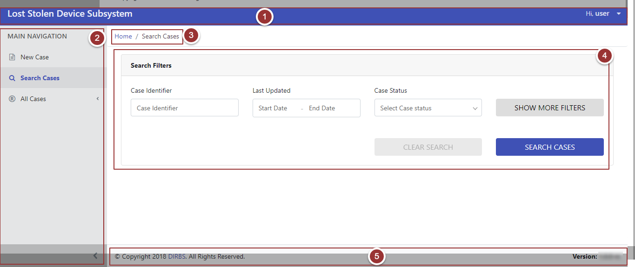

Figure 2–Portal Sections

## **Register New Case**

1. To report the incident, click on “New Case” tab
2. Enter the affected device description (i.e. Brand name, Model name, Physical description)
3. 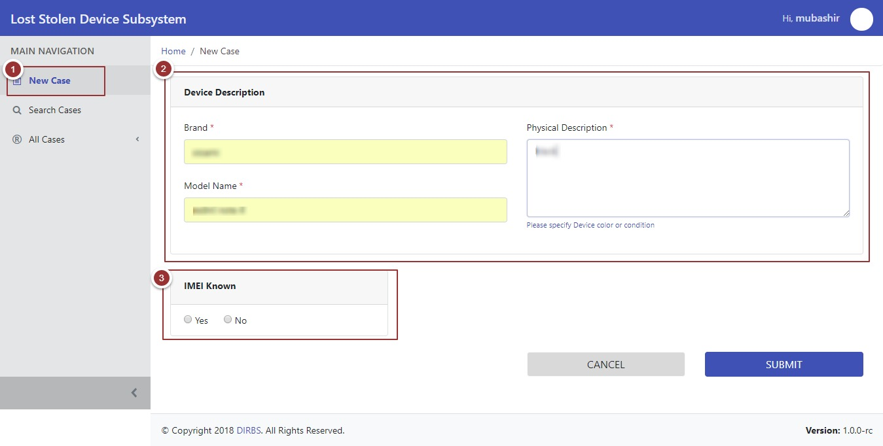Select the option “Yes” or “No” depending upon the information you have

Figure 3–New Case

## **IMEI Known**

1. If affected IMEI is known, select “Yes” option
2. To add affected MSISDN(s) click on “Add New” button

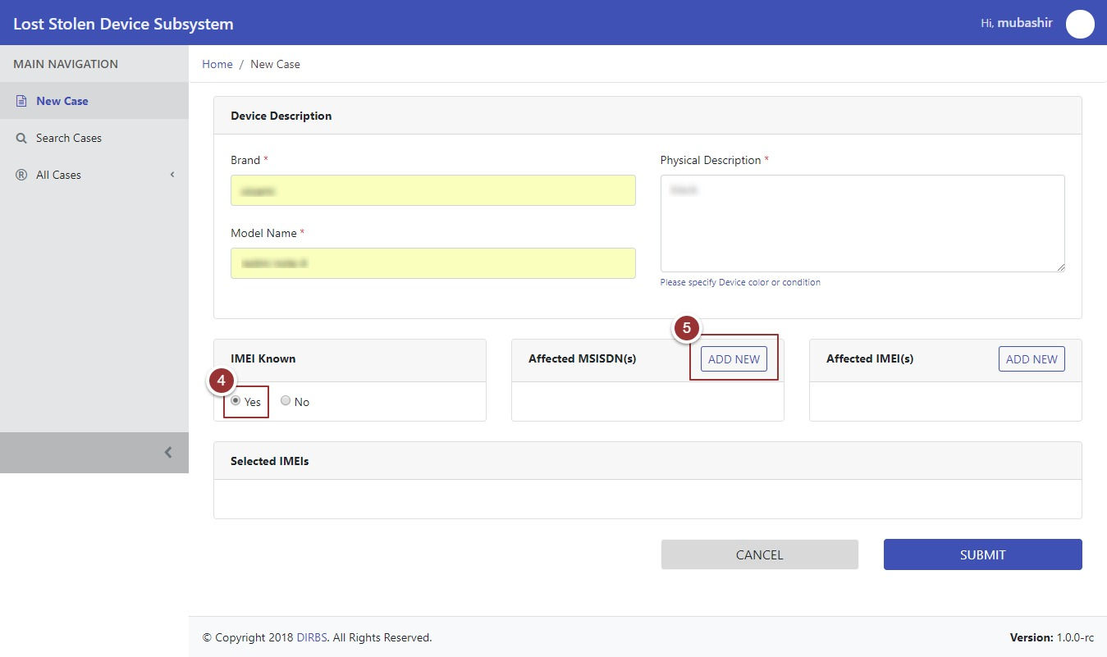

Figure 4–IMEI Known

1. The system prompts to enter MSISDN, enter the affected MSISDN

**Note:** MSISDN should be numeric and of 7-16 digits long.

1. Re-enter the affected MSISDN
2. Click the “Save” button

**Note**: For multiple MSISDNs perform steps 5- 8

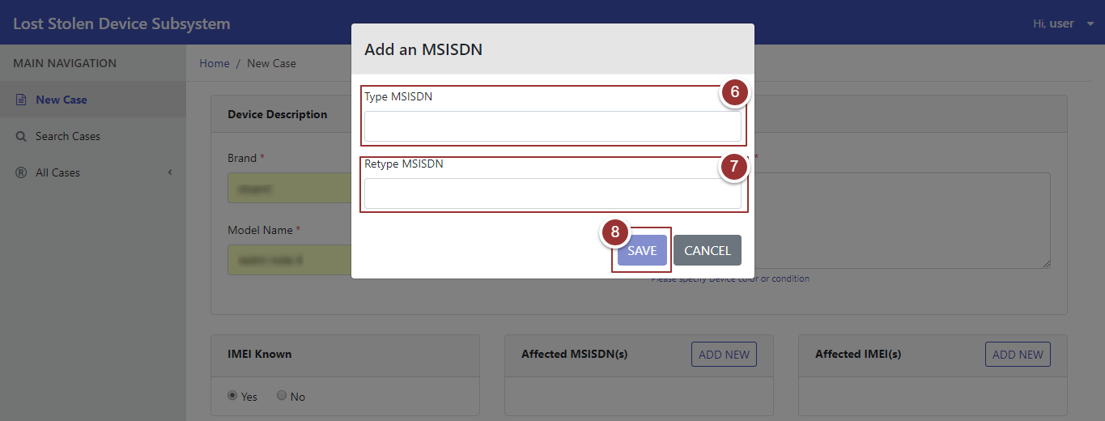

Figure 5–Add MSISDN

1. To add affected IMEIs, click on the” Add New “button

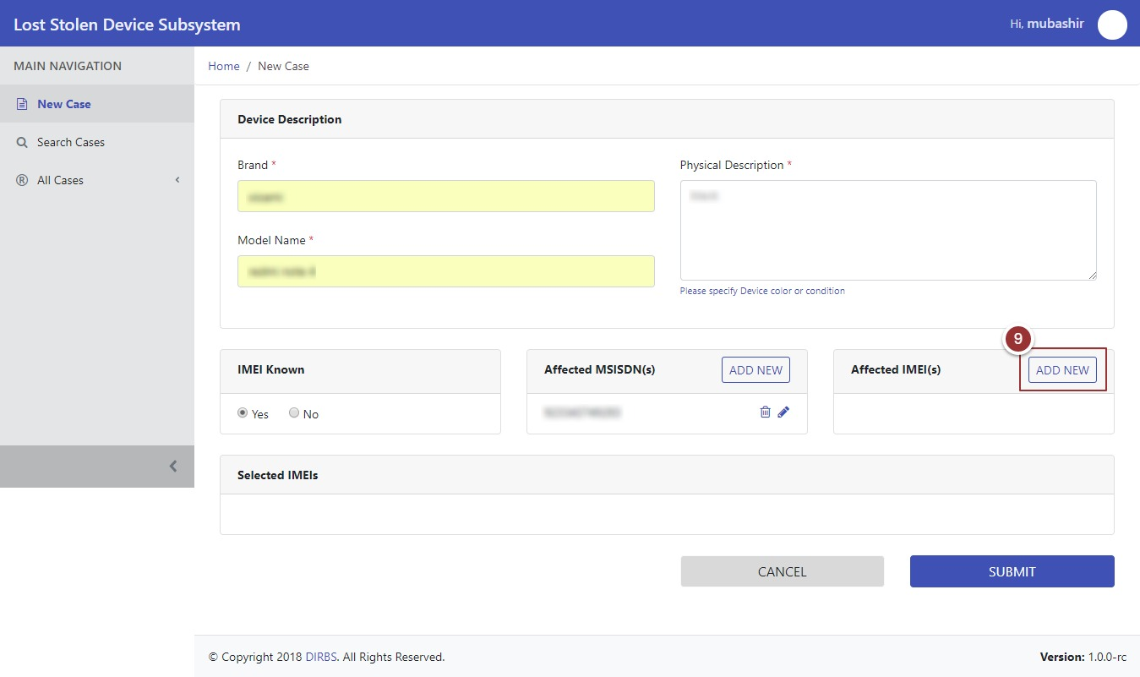

Figure 6–Affected IMEI(s)

1. The system prompts to enter IMEI, enter the affected IMEI

**Note**: IMEI can be of alphanumeric characters (0-9, A-F, a-f). The length of the IMEI should be between 14-16 characters.

1. Re-enter the affected IMEI
2. Click on the “Save” button

**Note**: For multiple IMEIs repeat steps 9- 12

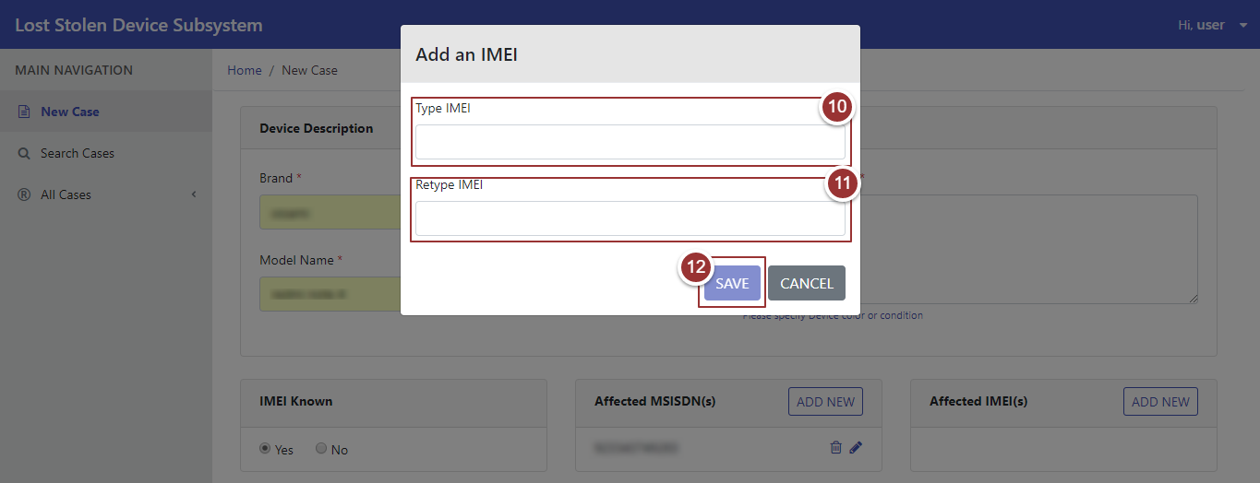

Figure 7– Add IMEI(s)

1. To verify associated MSISDNs with the device description click on “Get Details” button

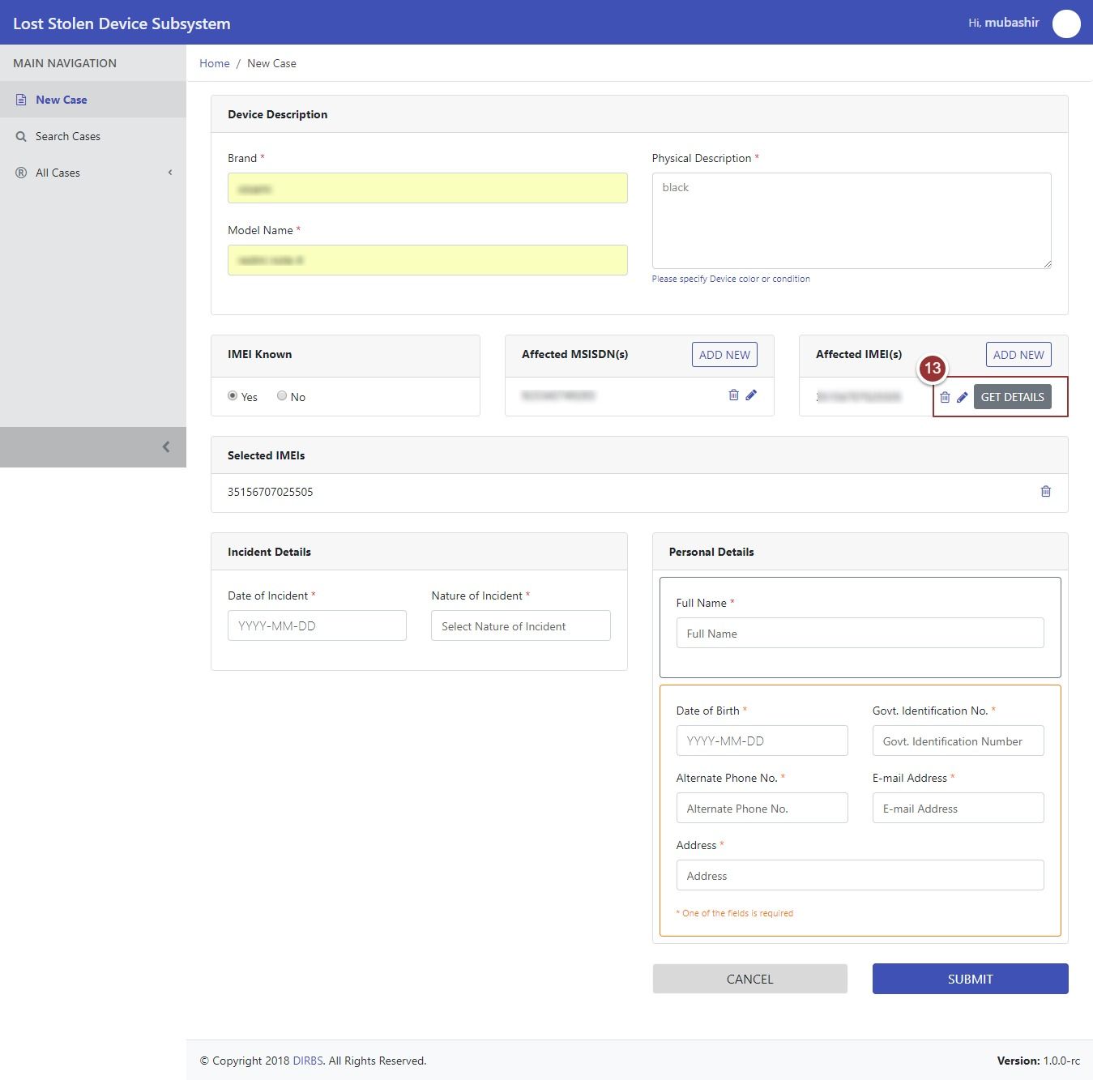

Figure 8–Get Details

1. A popup will appear containing device description and MSISDN, to see the device details, click on the “Show Device Details” button

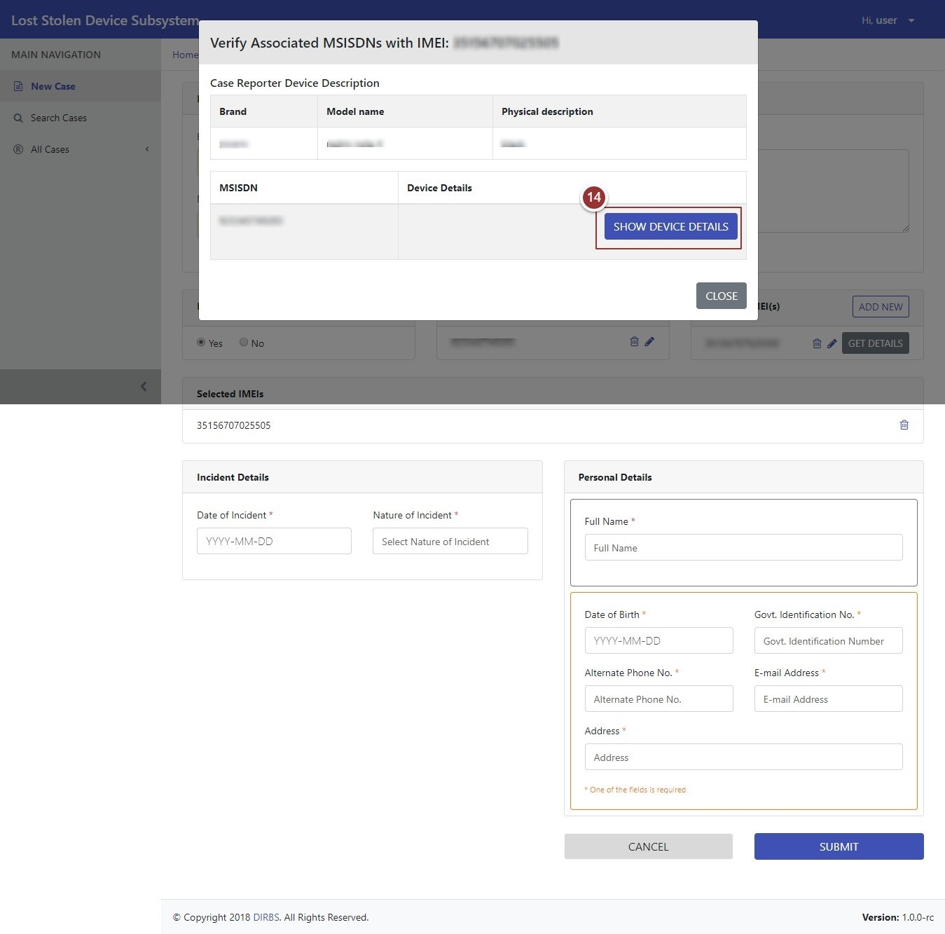

Figure 9–Show Device Details

1. The system displays device details, click on the “Close” button to proceed further

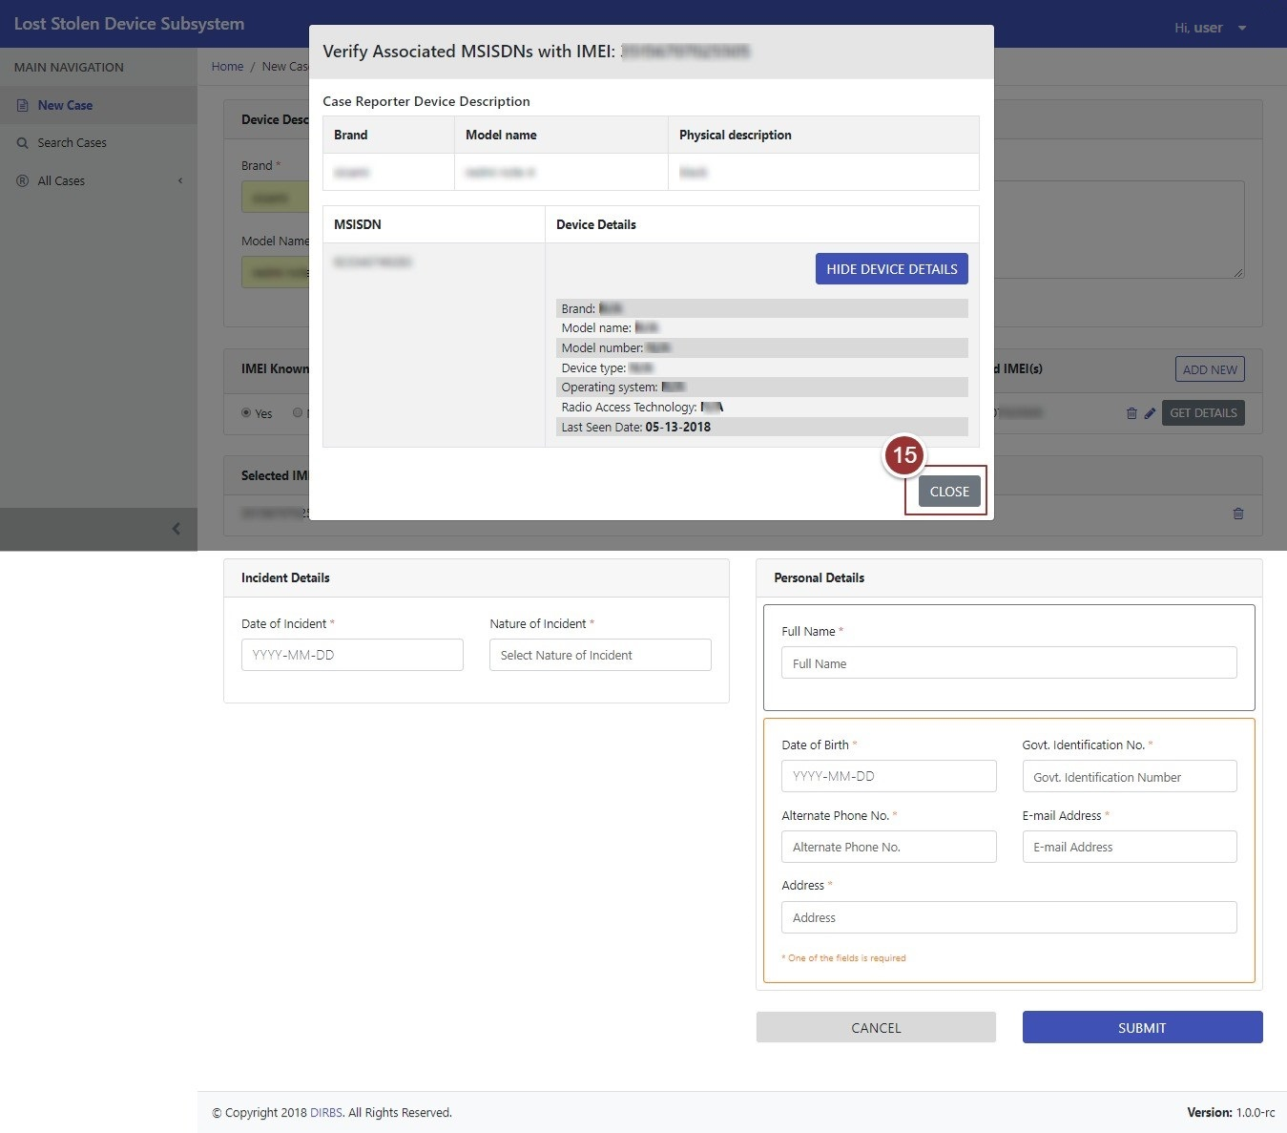

Figure 10–Show Device Details

## **Adding Incident & User Information**

1. Enter “Incident Details” i.e. Date and Nature of incident
2. Enter affected consumer’s “Personal Information” i.e. Full Name, Date of Birth (DOB), Address, Govt. Identification Number, Alternate Phone Number, Email Address

**Note** Full Name of the consumer is mandatory. From rest of the information any single information is required.

1. Click the "Submit" button

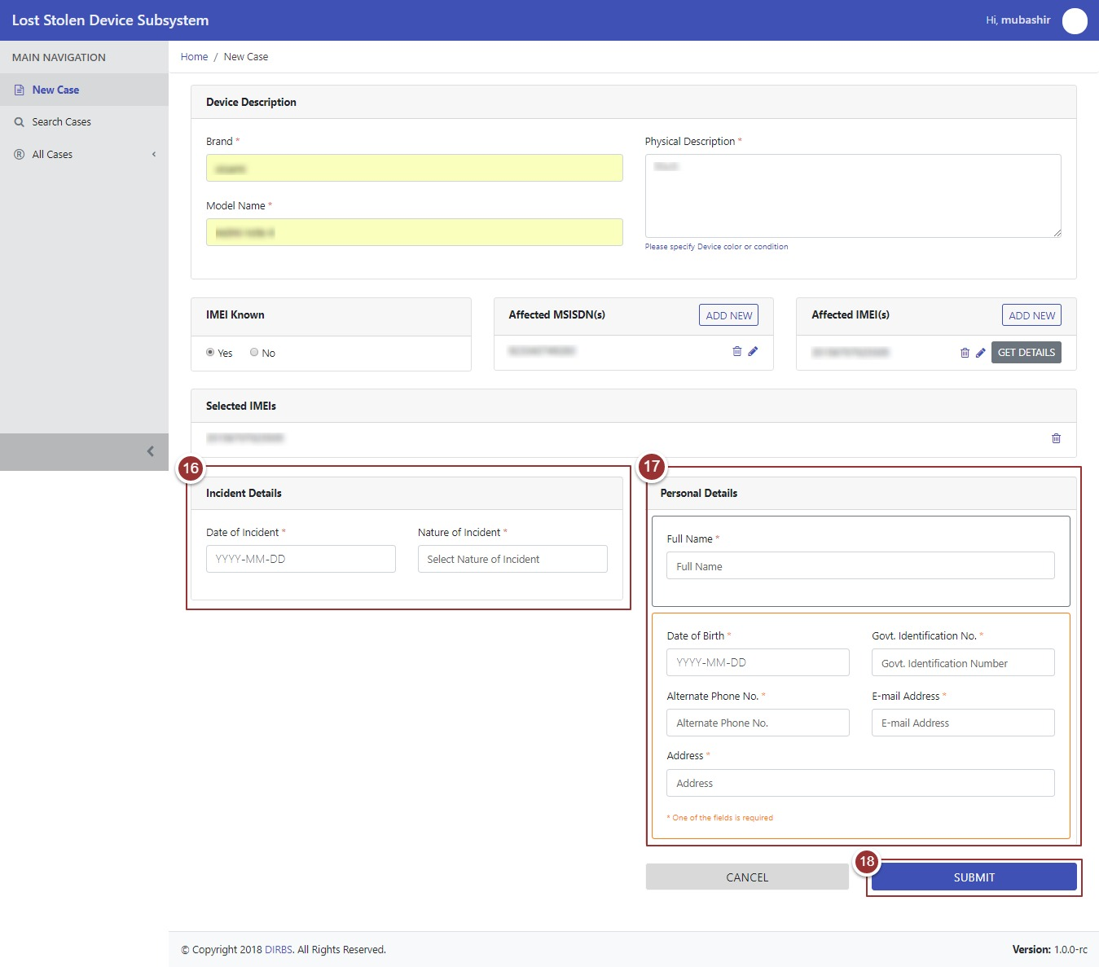

Figure 11–Personal Details

On submission of case, a page will appear that display the details (Confirmation message, Tracking ID, Status)

1. To view the case details, click on the “View Case” button

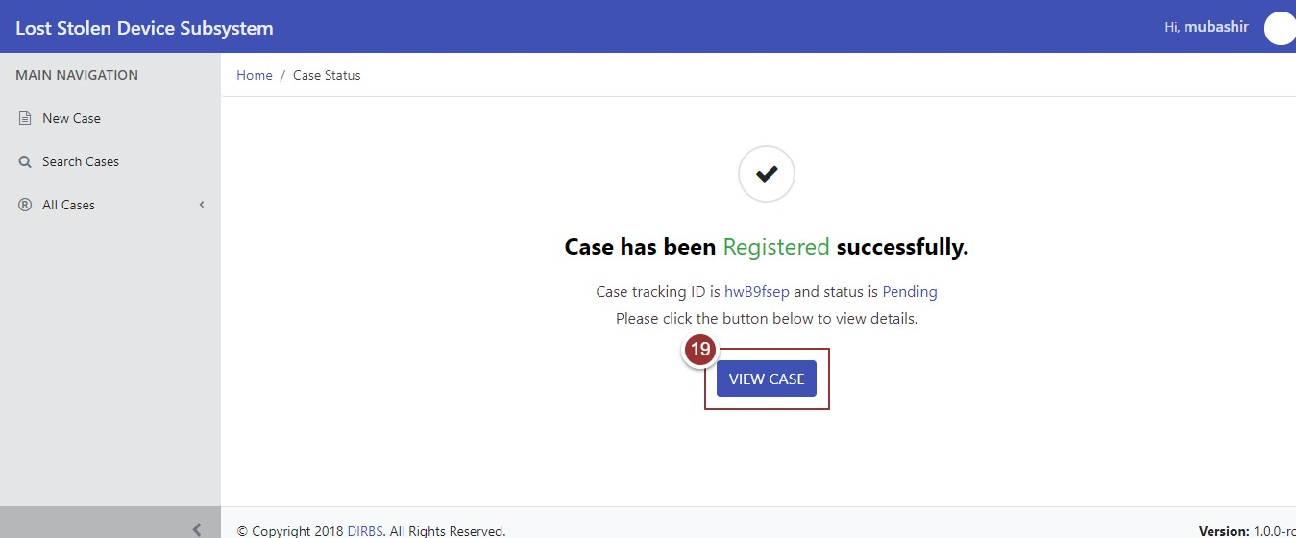

Figure 12–View Registered Case

## **IMEI Unknown**

**Note:** Perform step 1-3 as per section 2.3

4. If IMEI is unknown, select “No” option

5. Click on” Add New” button to add affected MSISDN(s)

.

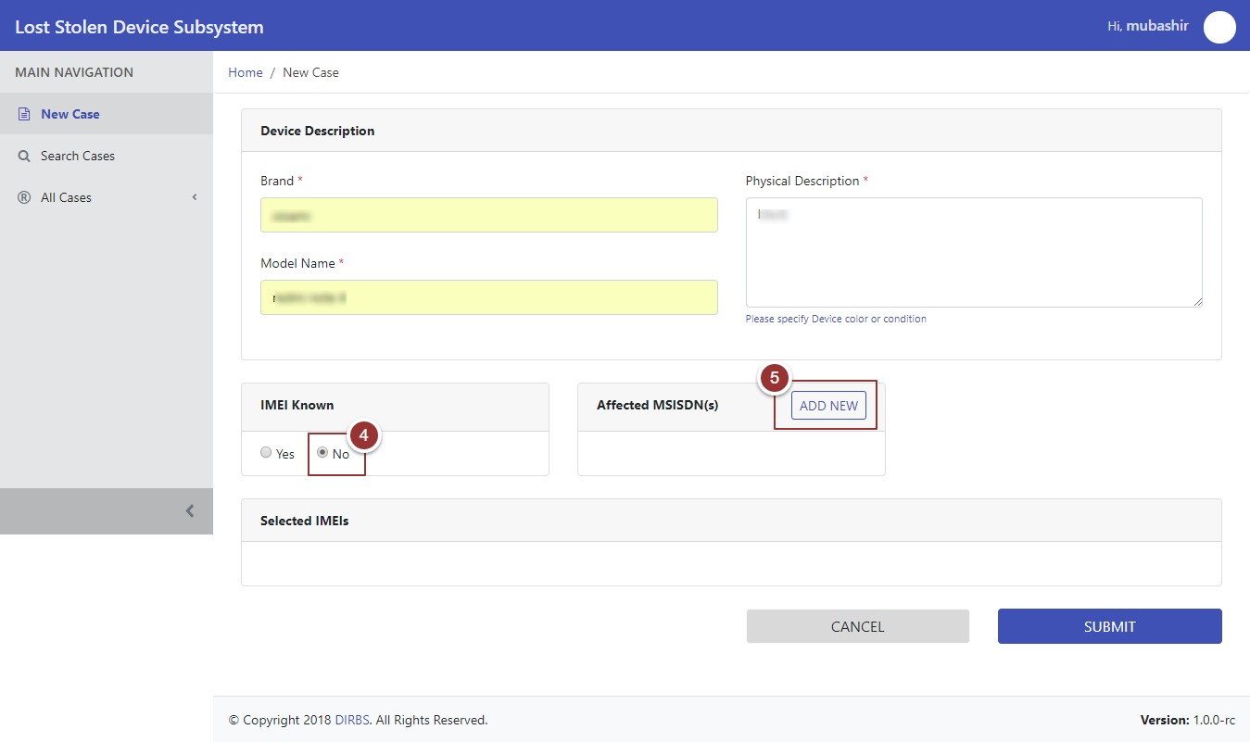

Figure 13–Unknown IMEI(s)

1. The system prompts to add MSISDN, enter the affected MSISDN

**Note:** MSISDN should always be numeric and of 7-16 digits long.

1. Re-enter the affected MSISDN
2. Click on the “Save” button

**Note:** For multiple MSISDN(s) perform steps 5-8

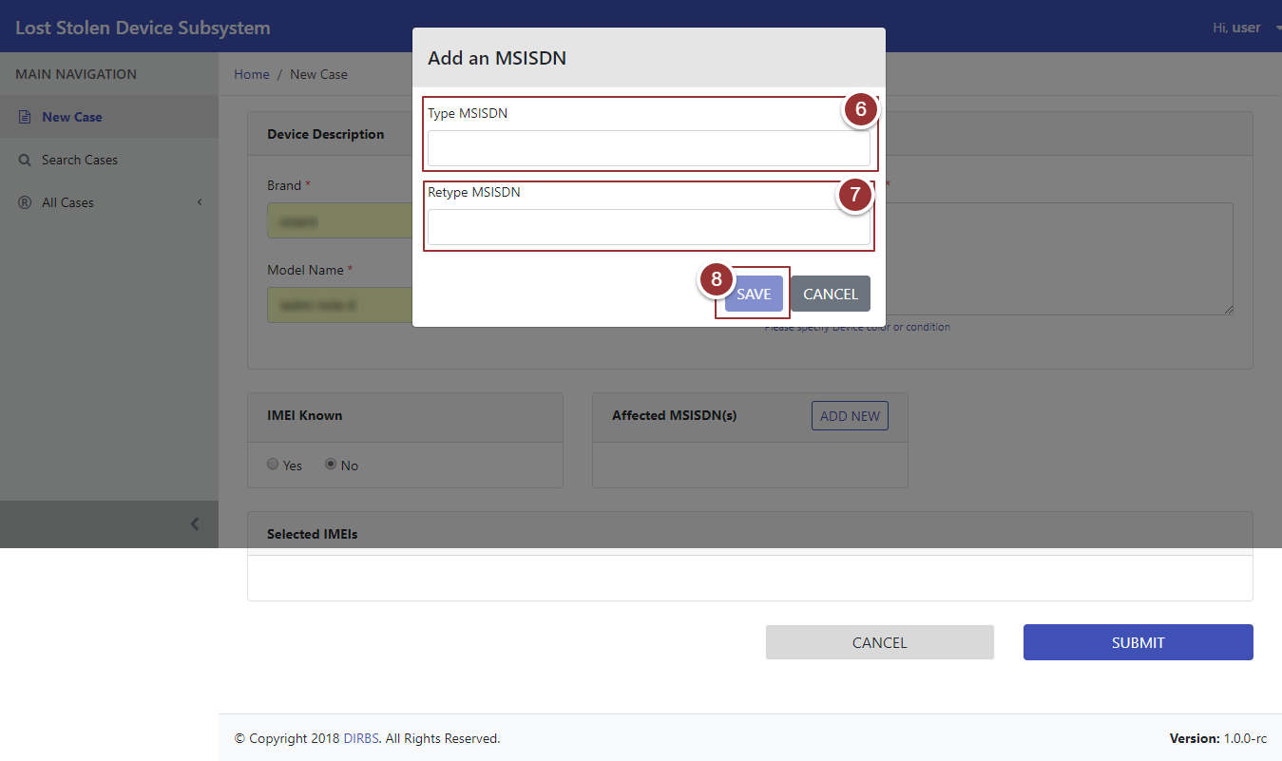Figure 14–Add MSISDN(s)

1. To see associated IMEI(s) with MSISDN, click on the “Fetch IMEI” button

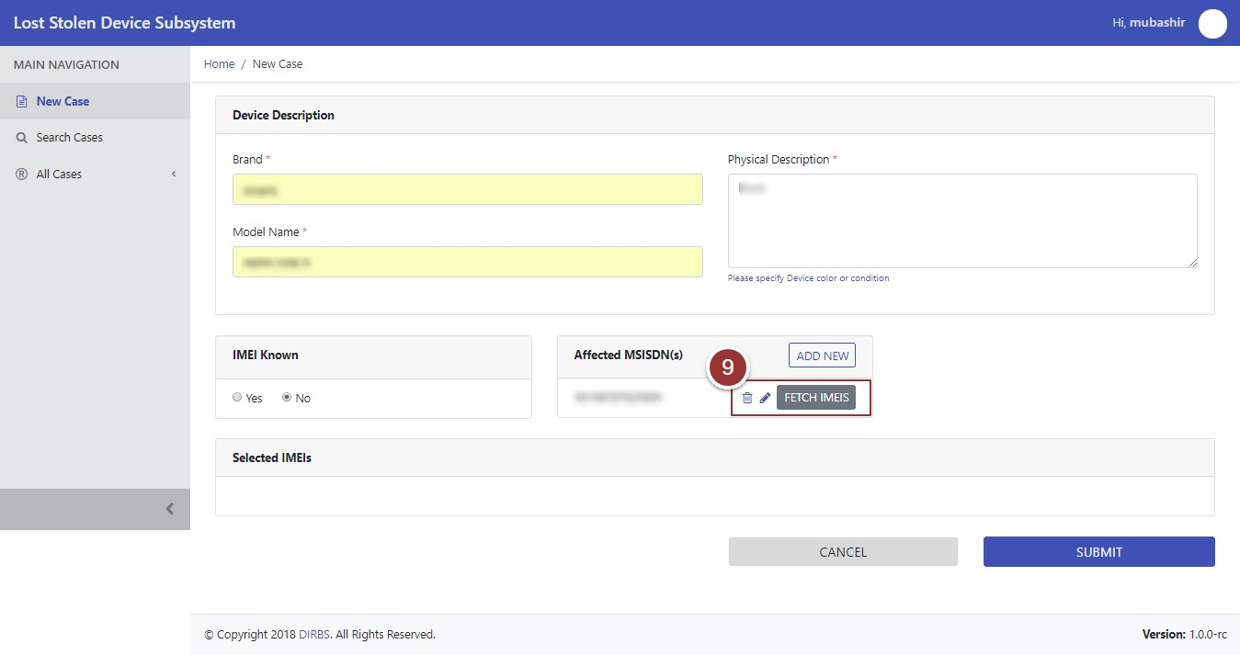

Figure 15–Fetch IMEI(s)

1. A popup window will display device description and associated IMEIs of the device with MSISDN. To see the device details click on the “Show Device Details” button

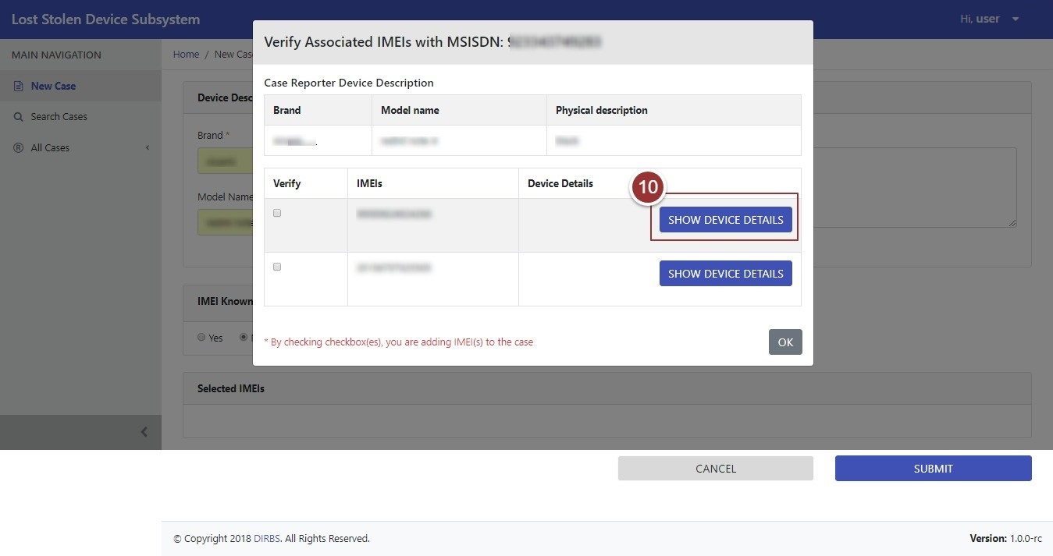

Figure 16–Verify Associated IMEI(s)

1. Verify the information and check the check box against the correct device details
2. Click on “OK” button, the device details would be added in the report

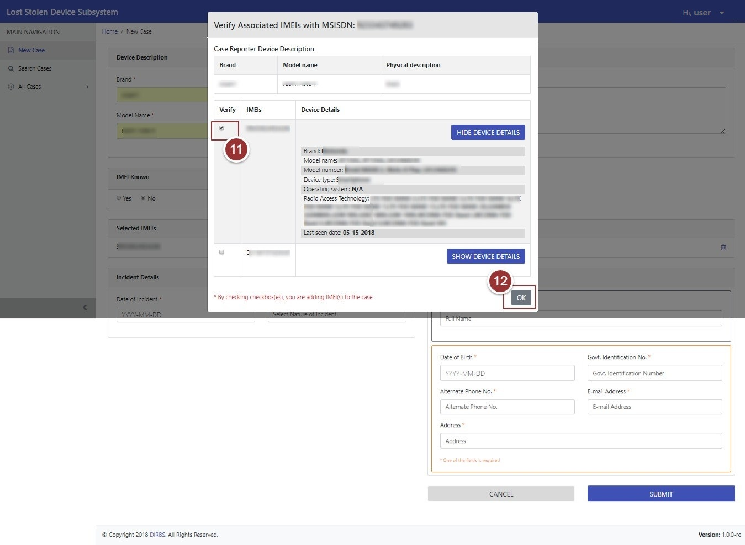

Figure 17–Device Details

**Note**: Perform Steps 16-19 as per section 2.3.1.1

## **Search Cases**

1. To search any particular case(s) click on “Search Cases” tab
2. Enter the known information (i.e. Case Identifier, Case Status, Last Updated etc.) for required case, for more search filters click on “Show More Filters” button and enter known information related to the case
3. Click on the “Search Cases” button to display the required case

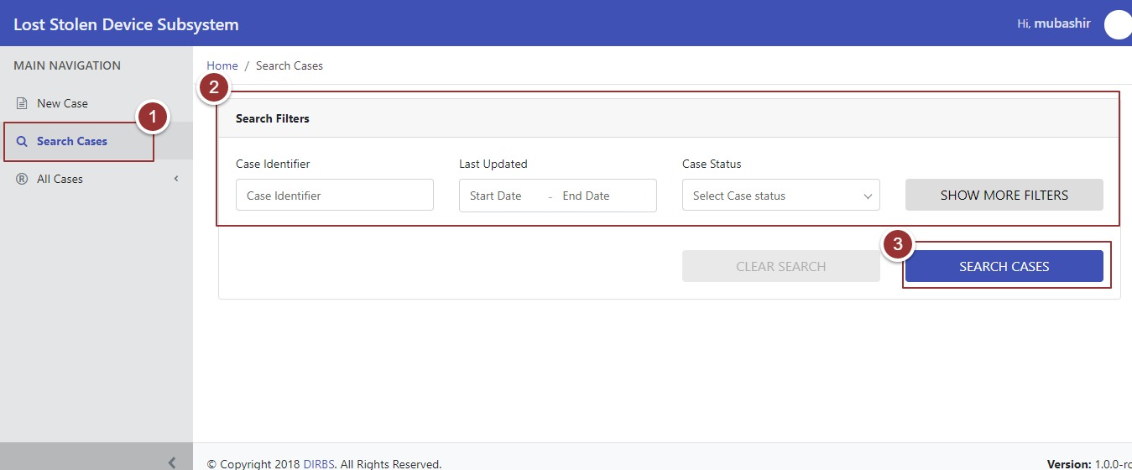

Figure 18–Search Cases

## **View All Cases**

To view all cases click on “All Case” tab, a drop down menu will appear displaying three options

* Pending Cases
* Blocked Cases
* Recovered Cases

## **View Pending Case**

1. Click on “Pending Cases” tab

System will display all pending cases along with the possible action (Update, Recover and Block) buttons.

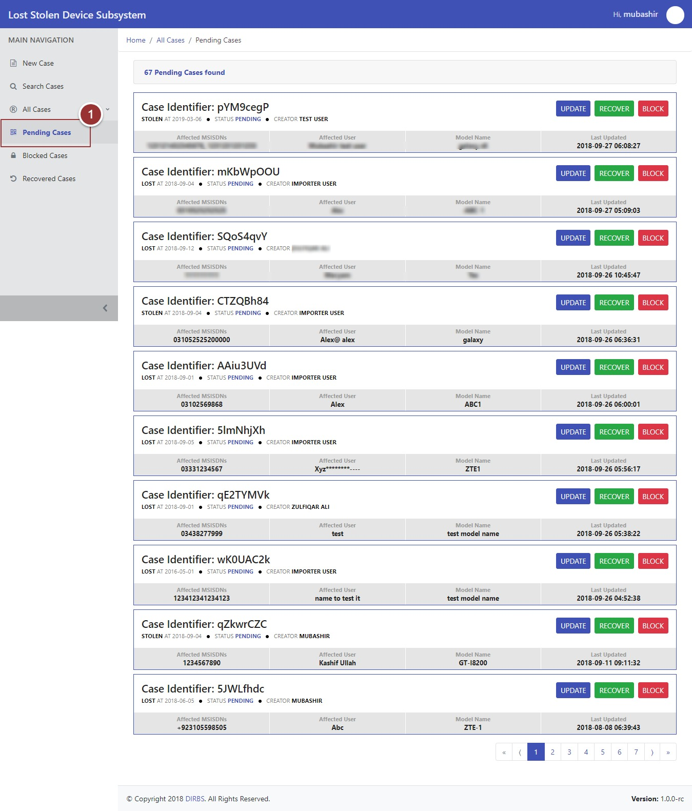

Figure 19–Pending Cases

1. To view case details click on the “Case Identifier”

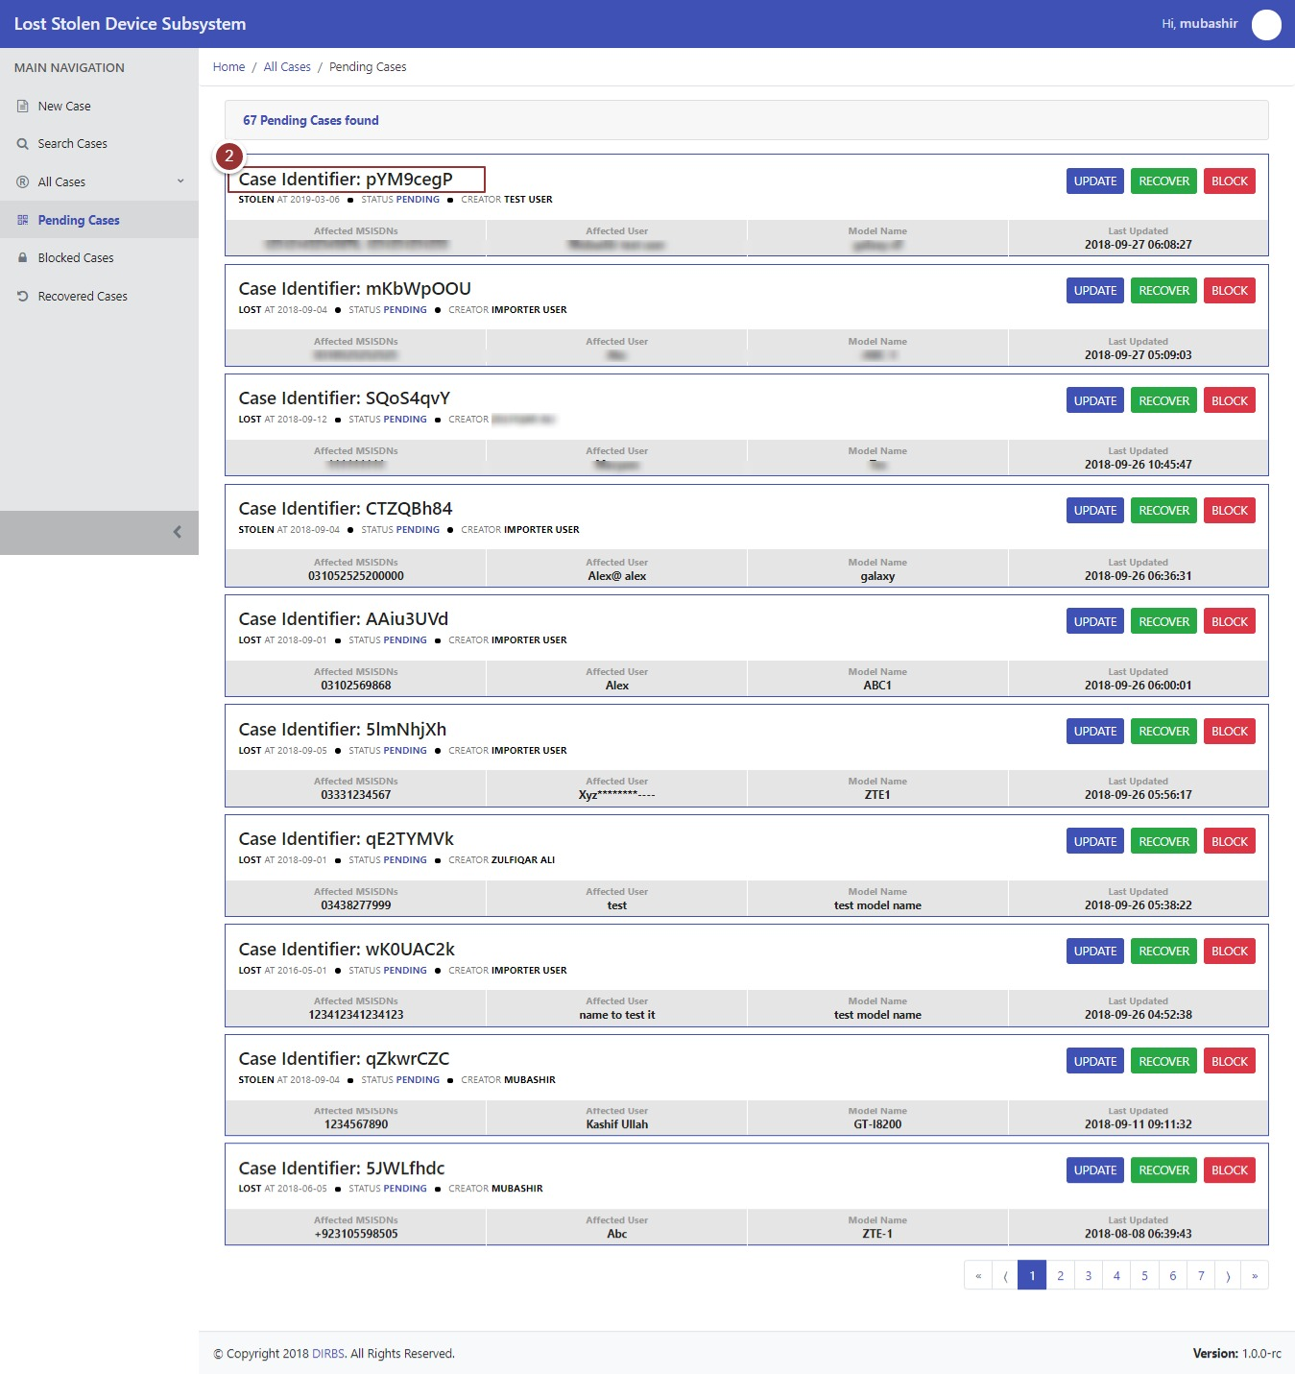

Figure 20–Case Identifier

All details of the case would be displayed i.e. last updated date, incident details, affected MSISDNs, affected IMEIs, personal details of the affected consumer and creator (the person who registered the case)

1. To change the status of the case, click on the required action button (Update, Block or Recover)

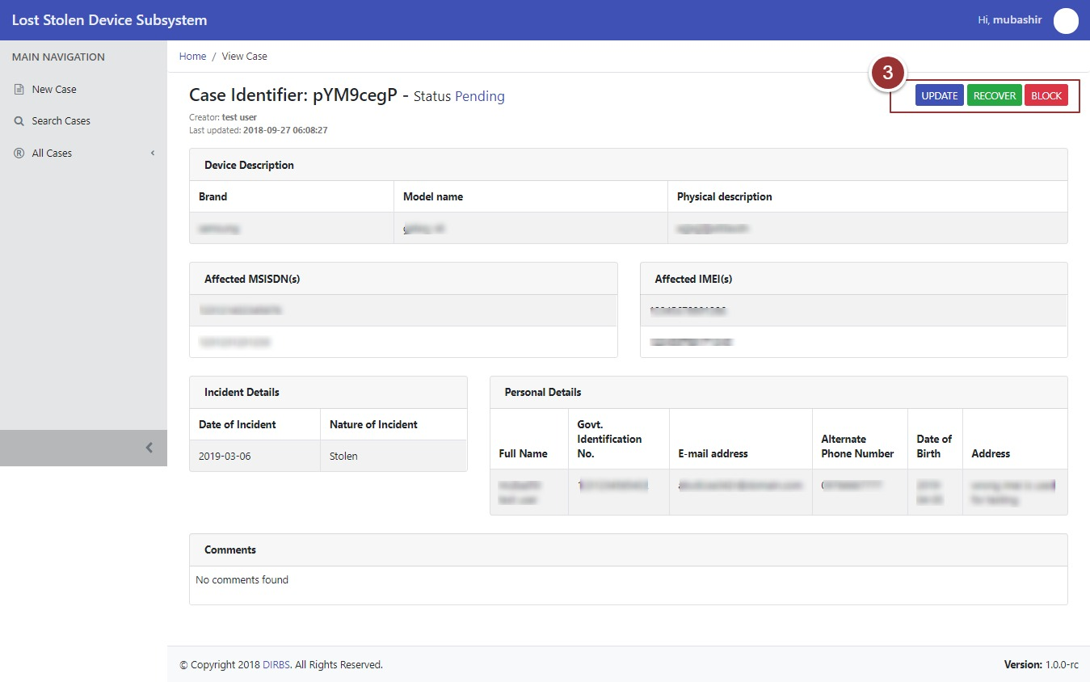

Figure 21–Reported Case Details page

## **Update Case**

Perform step 1.

1. Click on “Update” button against the required pending case, it will display all details of the particular case in which only personal details and comments section would be editable

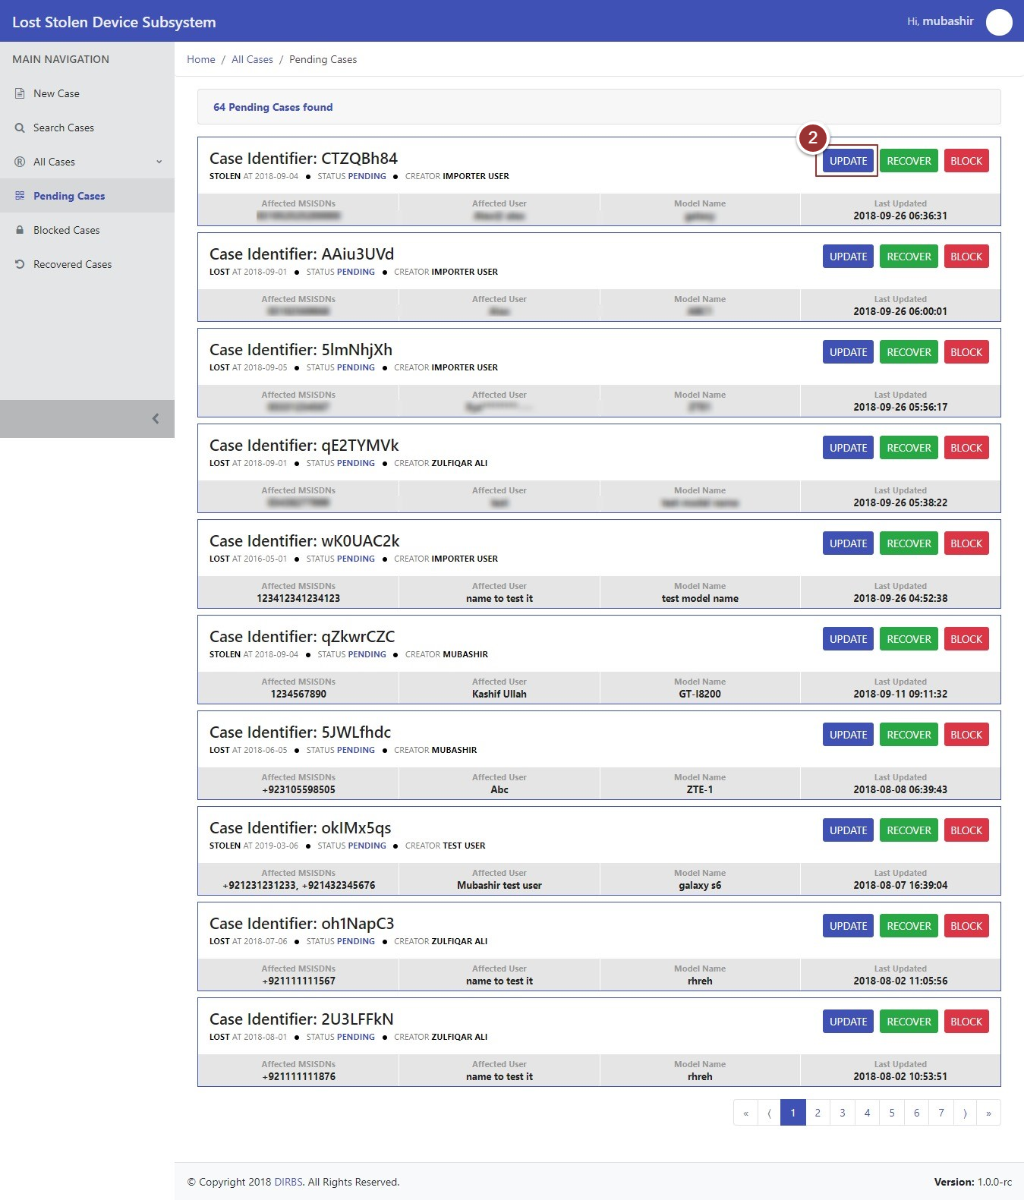

Figure 22–Update Case

1. Edit/ change the “Personal Details”

Enter comments in “Comment” field (if any)

Click on the “Submit” button to save the changes

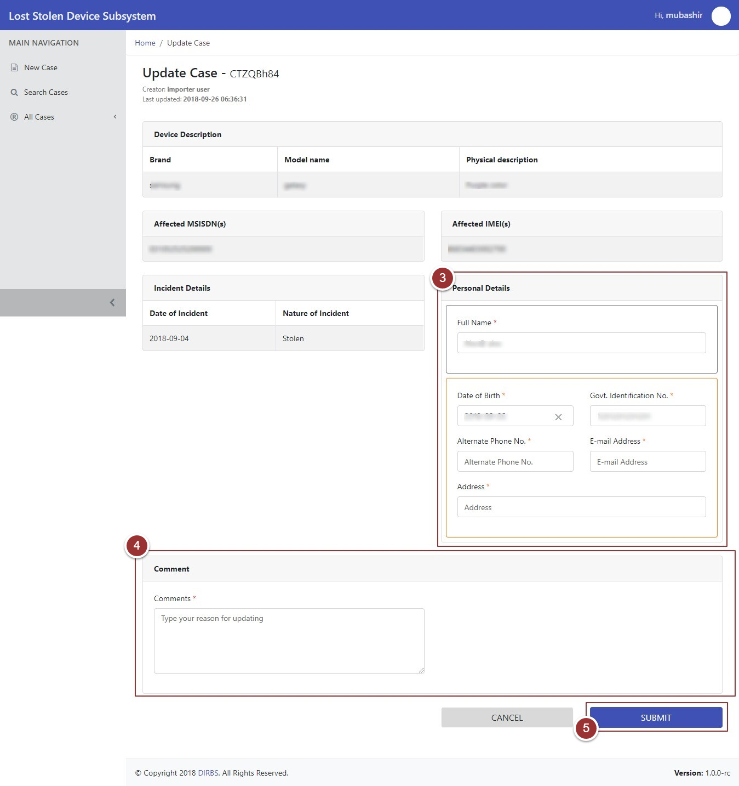

Figure 23–Update Personal Details

On Submission of case, a page will appear that displays the details (Confirmation Message, Tracking ID, Status)

To view the updated case click on the “View Case” button

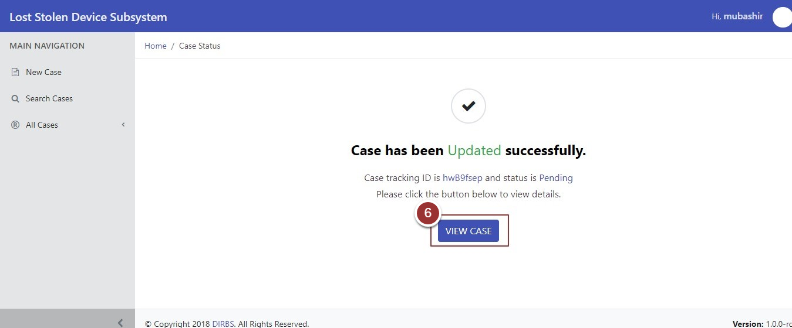

Figure 24–View Updated Case

## **Block Case**

Perform step 1.

1. To change the status of registered pending case as blocked case, click on the “Block” button. This will add all reported IMEI(s) in the blacklist

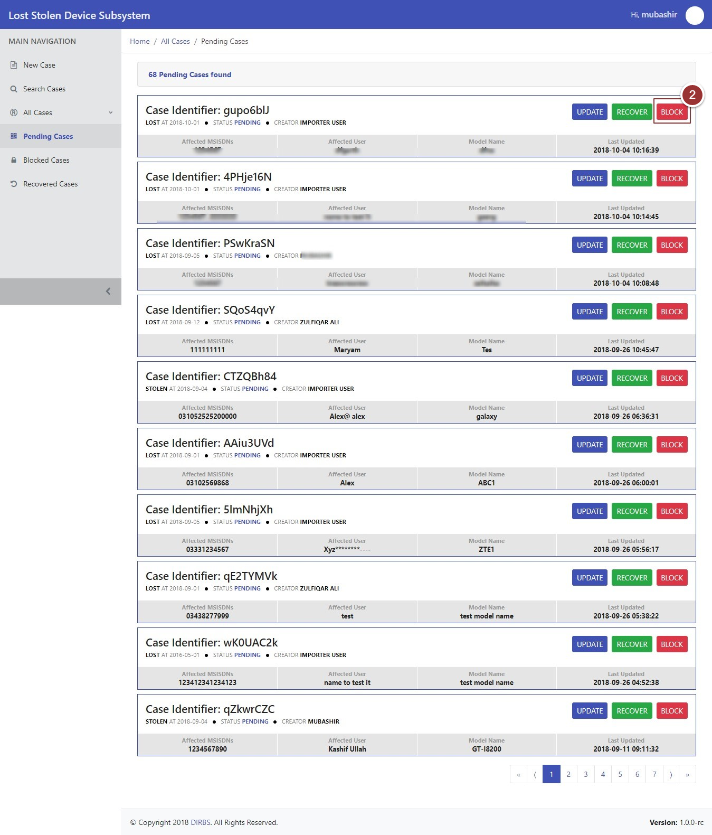

Figure 25–Block Case

1. The system prompts to add comment i.e. reason(s) to block, enter relevant comments
2. Click on the “Submit” button

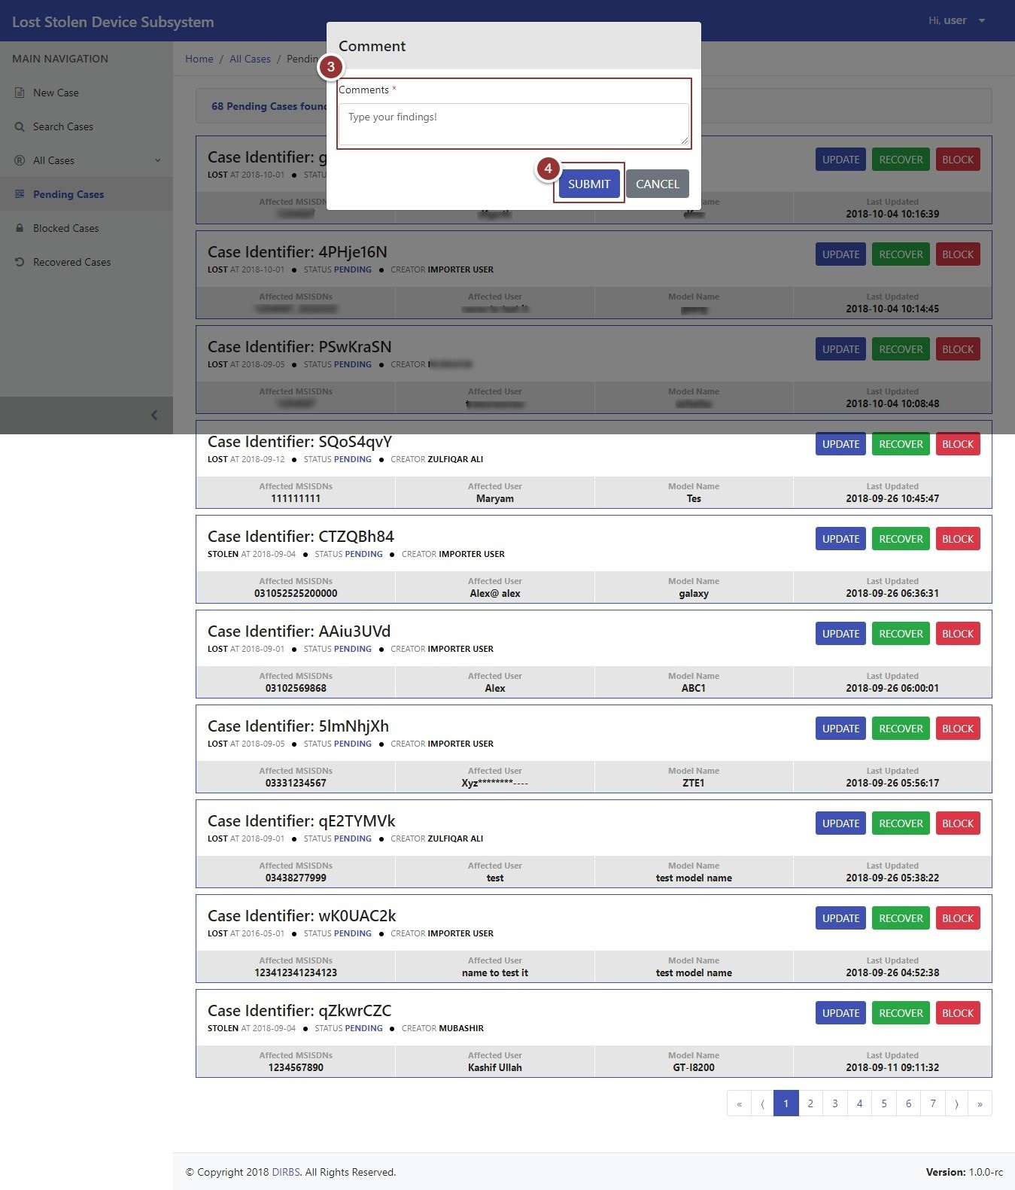

Figure 26–Update Comments of Pending Case

On submission of the case, a page will appear that displays the details (Confirmation Message, Tracking ID, Status)

1. To view the blocked case, click on the “View Case” button

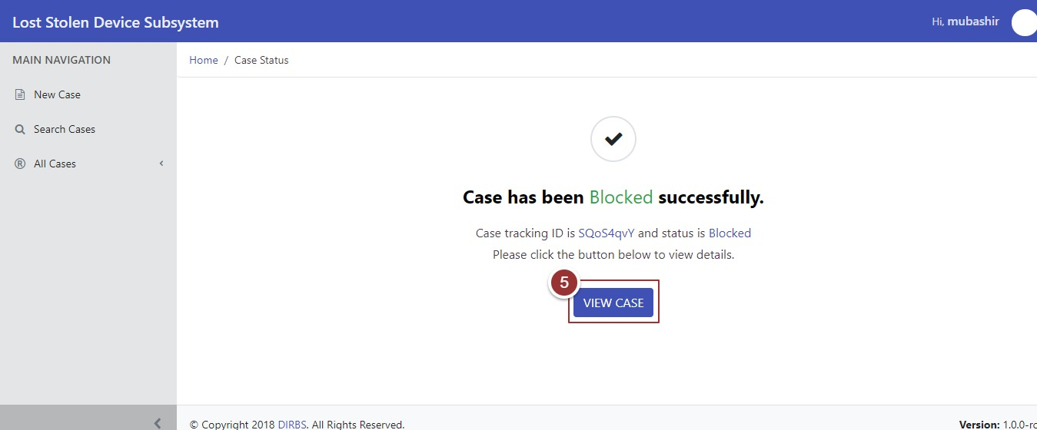

Figure 27–View Blocked Cases

## **Recover Case**

Perform step 1.

1. To change status of the case from pending to recover, click on the “Recover” button. This will remove the respective case from pending

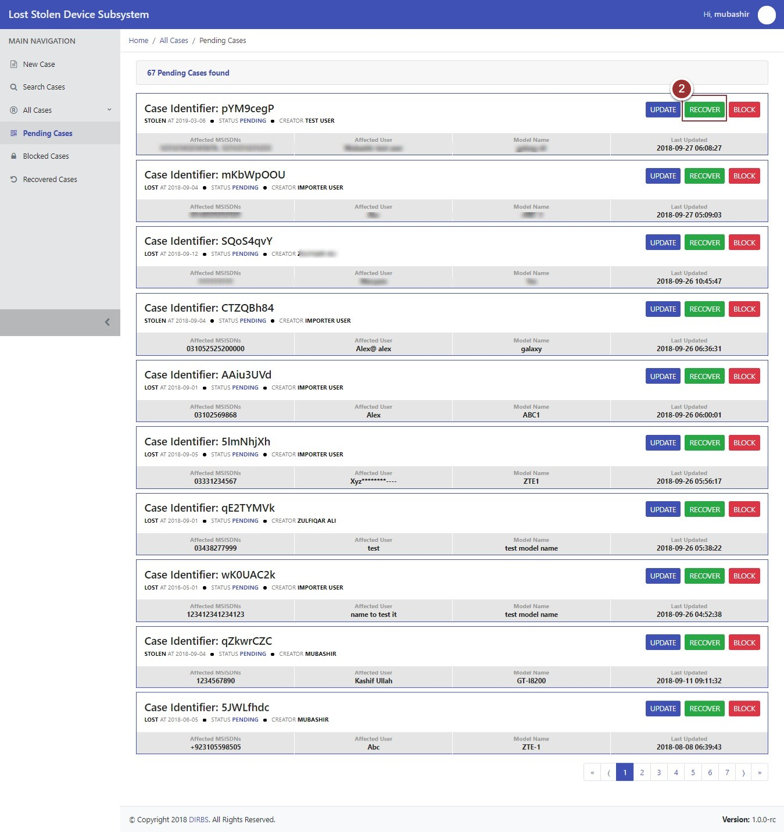

Figure 28–Recover Case

1. The system prompts to add comments, enter relevant comments
2. Click on the “Submit” button



Figure 29–Add Comments

On submission of the case, a page will appear that displays the details (Confirmation Message, Tracking ID, Status)

1. To view the recovered case, click on the “View Case” button

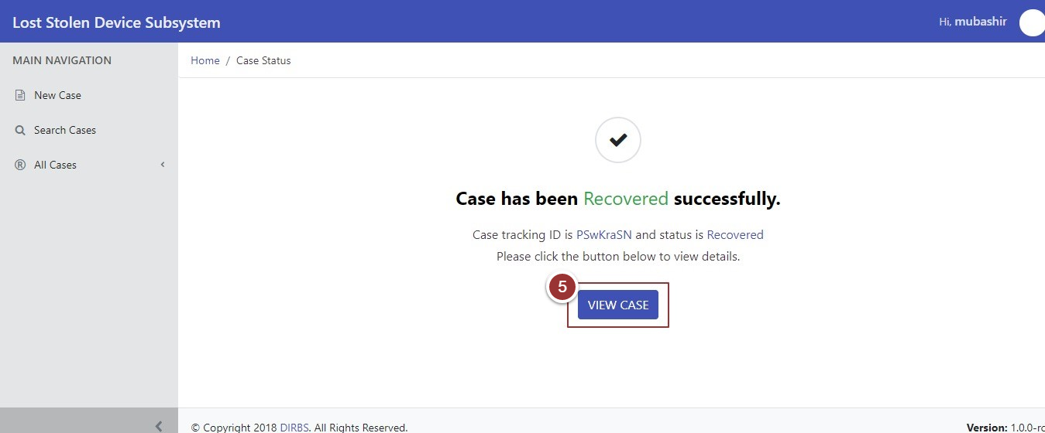

Figure 30–Recovered Case Status

## **View Blocked Cases**

1. Click on “Blocked Case” tab

System will display all blocked cases along with the action (Recover) button.

1. To change the status of the case from blocked to recover, click on the “Recover” button. This will remove all reported IMEI(s) from blacklist

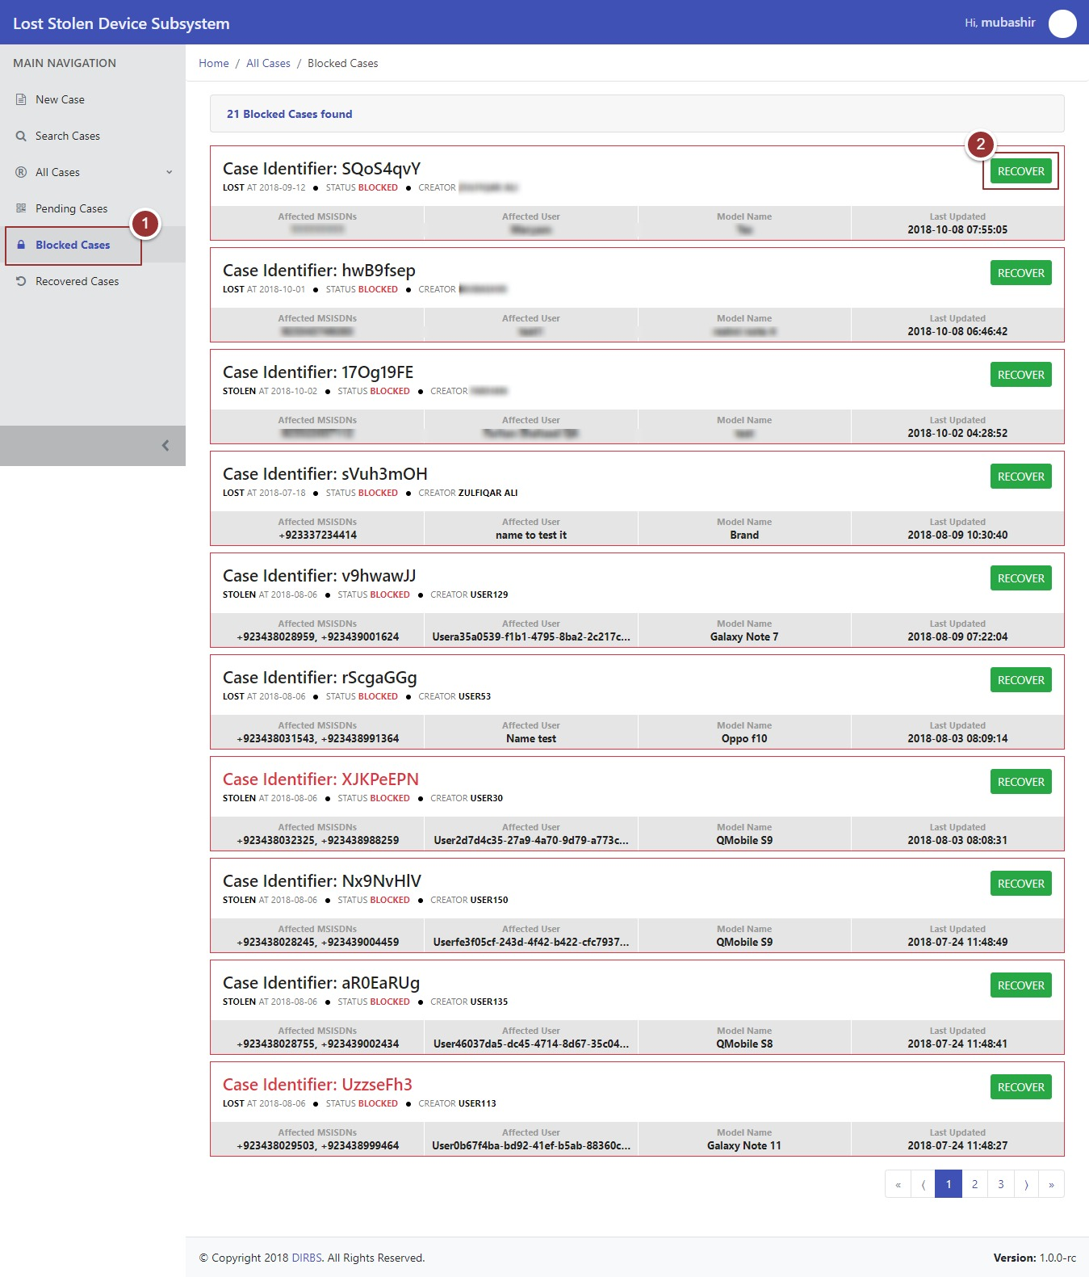

Figure 31–List of Blocked Cases

**Note**: Perform step 2-4 as per section 2.5.1.3

## **View Recovered Cases**

1. To view recovered cases click on “Recovered Cases” tab, system will display all recovered cases. To view the details of any recovered case click on Case Identifier of that particular case

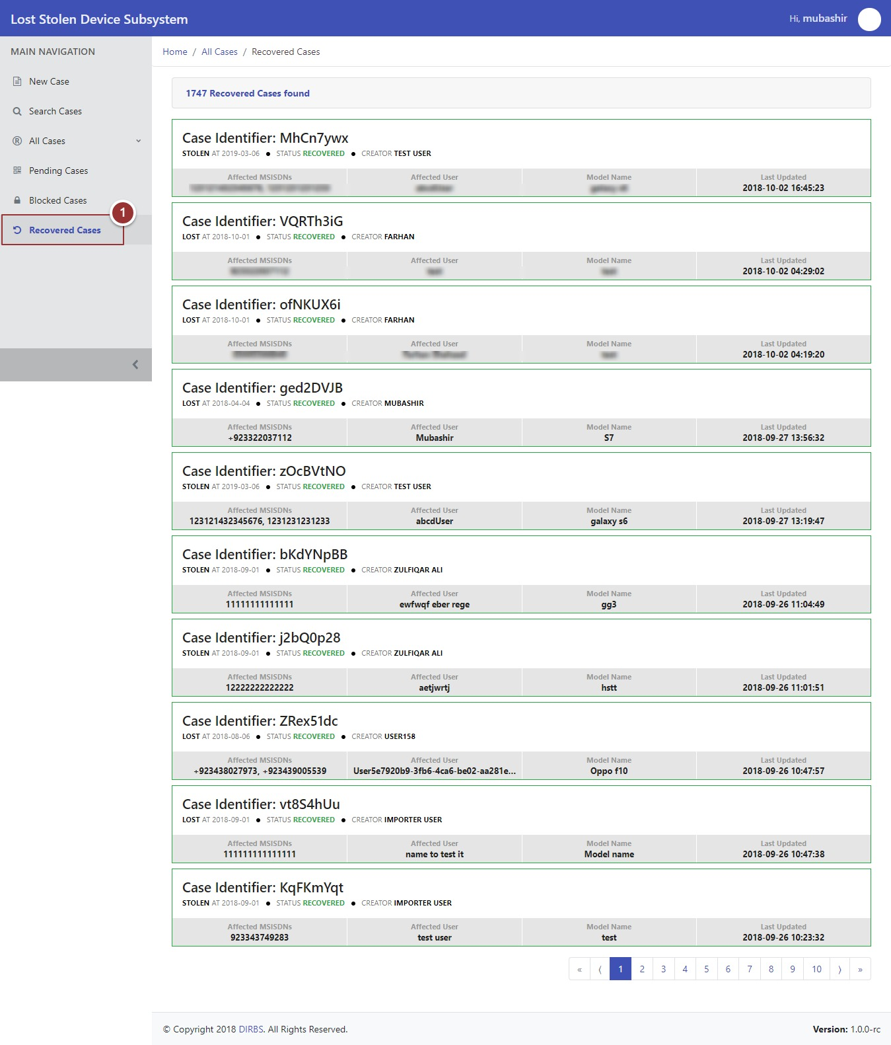Figure 32–List of Recovered Cases